

**Mini Project**

**on**

**Is Your Heart Healthy?**

**Submitted in Partial Fulfillment of the Requirement**

**For the Degree of**

**Bachelor of Technology**

**In**

**Computer Science and Engineering**

**By**

Rishabh Kumar (1902900100135)

Saksham Vashishtha (1902900100140)

Shivam Sharma (1902900100149)

**Under the Supervision**

**of**

**Ms. Jyoti Thakur**

AFFILIATED TO

**Dr. A.P.J. ABDUL KALAM TECHNICAL UNIVERSITY, UTTAR PRADESH,**

## LUCKNOW (ODD SEM, 2020-21)

**TABLE OF CONTENTS** Page

DECLARATION ................................................................................................... ii

CERTIFICATE ..................................................................................................... iii

ACKNOWLEDGEMENT .................................................................................. iv

CHAPTER 1 (INTRODUCTION) ............................................................. 1

1.1. Objective ................................................................................................ 1

1.2. Description .............................................................................................. 1

1.3. Tools and Technologies ................................................................................ 2

CHAPTER 2 (REQUIREMENT ) …………........................................................... 3

2.1. HARDWARE …........................................................................................ 3

2.2. SOFTWARE ........................................................................................... 3

CHAPTER 3 (FUTURE SCOPE)………... ......................................................... 4

CHAPTER 4 (DATASETS AND PLOTS) ............................................................ 5

CHAPTER 4 (CONCLUSIONS) ............................................................ 9

REFERENCES... .................................................................................................... 10

## DECLARATION

We hereby declare that this submission is our own work and that, to the best of our knowledge and belief, it contains no material previously published or written by another person nor material which to a substantial extent has been accepted for the award of any other degree or diploma of the university or other institute of higher learning, except where due acknowledgment has been made in the text.

Signature :

Name : Rishabh Kumar, Saksham Vashistha, Shivam Sharma

Roll No. : 1902900100135,1902900100140,1902900100149

Date : 13 January 2021

# CERTIFICATE

This is to certify that Project Report entitled “ Is Your Heart Healthy ?? ” which is submitted by Rishabh Kumar (135), Saksham Vashistha (140), Shivam Sharma (149) in partial fulfillment of the requirement for the award of degree B. Tech. in Department of Computer Science and Engineering of AKTU, is a record of the candidates own work carried out by them under my/our supervision. The matter embodied in this thesis is original and has not been submitted for the award of any other degree.

**Date:** 13 January 2021 **Supervisor : Ms. Jyoti Thakur**

## ACKNOWLEDGEMENT

It gives us a great sense of pleasure to present the report of the B. Tech Project undertaken during B. Tech. Second Year. We owe special debt of gratitude to Professor Jyoti Thakur, Department of Computer Science & Engineering, ABES Institute of Technology, Ghaziabad for his constant support and guidance throughout the course of our work. His sincerity, thoroughness and perseverance have been a constant source of inspiration for us. It is only his cognizant efforts that our endeavours have seen light of the day.

We also take the opportunity to acknowledge the contribution of Doctor Rizwan Khan, Head, Department of Computer Science & Engineering, ABES Institute of Technology, Ghaziabad for his full support and assistance during the development of the project.

We also do not like to miss the opportunity to acknowledge the contribution of all faculty members of the department for their kind assistance and cooperation during the development of our project. Last but not the least, we acknowledge our friends for their contribution in the completion of the project.

*Signature :*

*Name :* Rishabh Kumar, Saksham Vashistha, Shivam Sharma

*Roll No. :* 1902900100135,1902900100140,1902900100149

*Date :* 13 January 2021

# CHAPTER 1

**INTRODUCTION**

* 1. **Objective**

In this Modern era, we Humans are trying to make our life easy-to-live. we’re depending on technology and machines. Somewhere, with the increase in the production of machines, we also damage our nature in some aspects. Everyone wants to live their life comfortably. Over some past years, most of the countries took a step to reduce this damage to nature, but they’re still trying to reduce it. The damage to nature can cause pollution in nature which will affect humans. That’s why we provide a platform where users can check for their health. They can check Is Their Heart Healthy? or they need to consult a doctor.

* 1. **Description**

The Application consists of 5 Tabs: Home, Hospitals, Store, Graph, COVID-19.

The Homepage is subdivided into 3 sections.

* Carousel, from where users can directly visit Best 3 hospitals websites.
* Prediction Page link, is formatted as Check button, under Is your Heart Healthy Enough?
* BMI calculator (constructed using JavaScript), where user can check their BMI level, and it returns a value with a background colour of progress bar ranging different BMI categories.

Hospitals, this section contains a Google MAP, where users can access the address or location of the best hospitals across the world.

Graph, this section contains population rates (growth and death rate) of different countries over the past 70 years [excluded COVID deaths].

Store and COVID-19 are linked to 3rd party Applications, Store: Medlife.com, COVID: covid19india.org

* 1. **Tools and Technologies used**
     1. **Python**

Python isa high-level, interpreted, general-purpose language, created by Guido-van-Rossum and released in 1991. It is open-source, supported by many individuals. Python’s design philosophy emphasizes code readability with its notable use of significant whitespaces (known as, indentation). Its Language constructs and object-oriented approach aim to help programmers write clear, logical code for small- and large-scale projects.

* + - 1. **Pandas**

Pandas is a python package used to manipulate and for analysis of datasets. It is an open-source, fast and a flexible library.

* + - 1. **Matplotlib**

Matplotlib is a python package used to visualize data. It is an open-source library, mostly used to produce high-quality visualization of data in the format of lines, bar graphs, pie charts, etc.

* + - 1. **Seaborn**

Seaborn is a python package used to visualize data. It is an open-source library, which works same as matplotlib but with more formats, and less syntaxes.

* + - 1. **Scikit-Learn**

Scikit-Learn, is a python package consist of different types of algorithms used in machine learning like, clustering, regression, Support Vector Machines, Classifications, etc.

* + - 1. **Joblib**

It is a python library used in lightweight pipelining.

* + - 1. **Django**

Django is an open-source, python-based web framework that follows the pattern of model-templates-view.

* + 1. **HTML, CSS and JS**

HTML (Hyper Text Mark-up Language) is a mark-up language, commonly used to design webpages. It can provide Basic Framing of Web Pages, which can be further styled using CSS (cascading Style Sheets), and assisted using scripted languages likeJS(Java Script)**.**

# CHAPTER 2

**REQUIREMENT**

**Hardware Requirement**

* Physical Machine
* CPU: 2x64-bit, 2GHz+ or better
* Minimum RAM: 4GB (Recommended 8GB or higher).
* Hard-Disk Space: 15GB (including all Software).
* Internet access.

**Software Requirement**

* Operating System (Windows 7 or higher).
* Visual Studio Code (or any other Editor).
* Google Chrome (or any other Browser).
* Anaconda (latest release).

# CHAPTER 3

# FUTURE SCOPE

This Project can Predict that a Human Heart is healthy or not, that Human has any Disease or not. He/she should consult a doctor or not. In this Matter, the best accuracy of the prediction model is Highly recommended, and the accuracy of our Model is only 72%. In future, we will try to increase its accuracy by providing it different dataset (if available), or by testing and applying different boosting techniques or make predictions using CNN techniques.

Secondly, the project consists of two 3rd party applications, Shop and COVID Tracker. We would change it too by creating our own interactive application, where, in shop section, we would suggest best online price of a medicine over Internet.

Lastly, the Donation page also needs to attach with some Payment Gateway, and we’ll try to improve it by using Blockchain Concepts.

# CHAPTER 4

# DATASETS AND PLOTS

**DATASET USED**

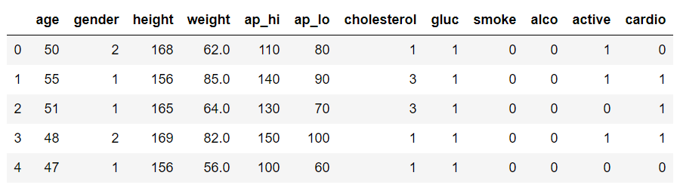

**Fig. 1. Dataset used in prediction**

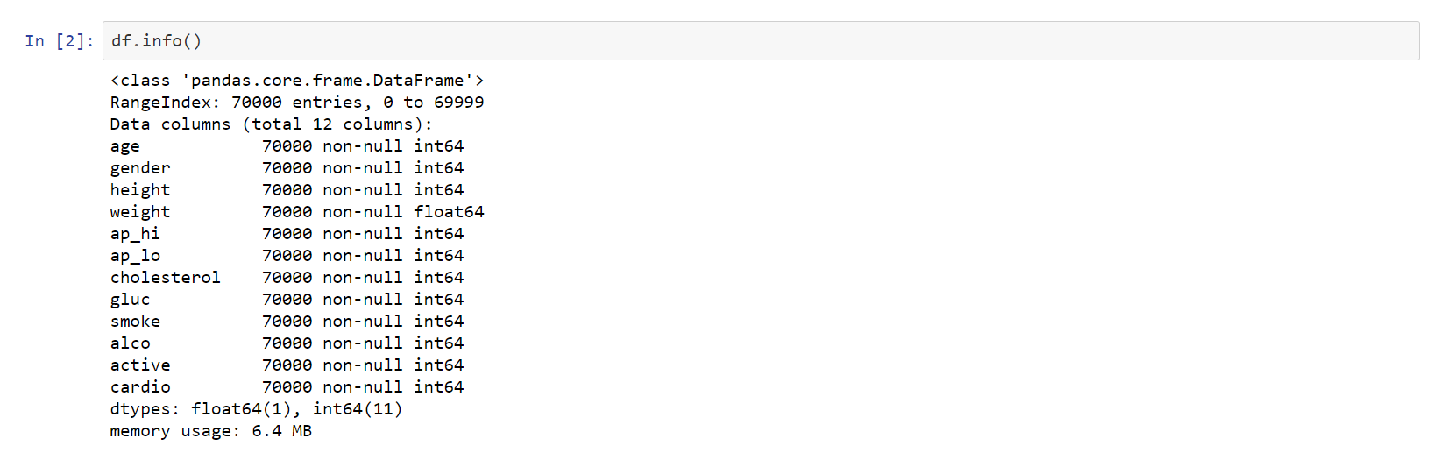

**Fig. 2. Features and Entries of Dataset**

Above Figure shows that there are no NULL values provided in data set and all values are of type Integer (except weight, which is float).

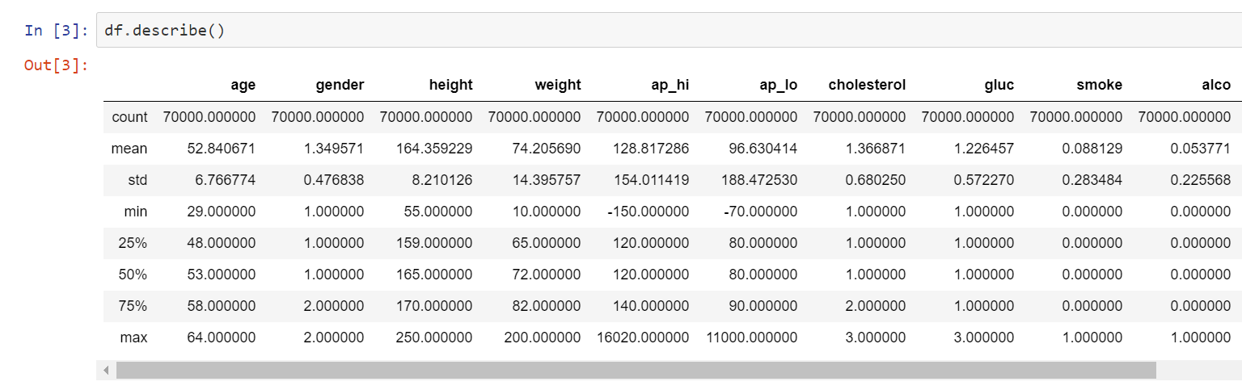

**Fig. 3. Description of Dataset**

**PREDICTION CODE**

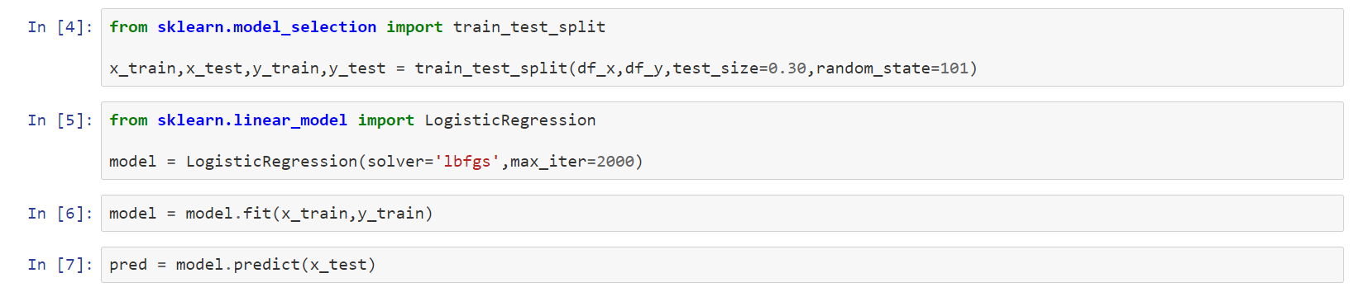

**Fig. 4. Prediction using sklearn library**

Above Figure shows the code of prediction model using sklearn library of python language. The Dataset provided lies under the Binary Classification Problem, where target value is given in Binary Values (0 or 1). To solve this type of problem, the best algorithm is Logistic Regression, which predicts a value in binary numbers.

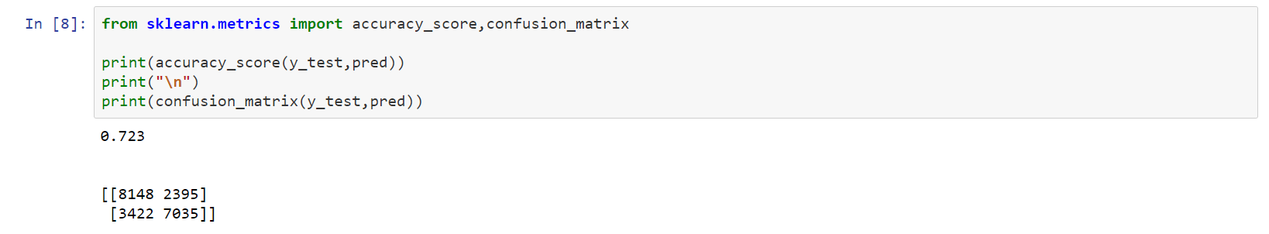

**Fig. 5. Accuracy Score**

|  |  |  |
| --- | --- | --- |
|  | Predicted NO | Predicted YES |
| Actual NO | 8148 | 2395 |
| Actual YES | 3422 | 7035 |

Code shown in the above figure calculates Accuracy of Prediction, based on Confusion Matrix.

Confusion Matrix =

|  |
| --- |
| TP+TN |
| ( TP+TN+FP+FN ) |

Accuracy =



**Fig. 6. Make New Prediction using above Model**

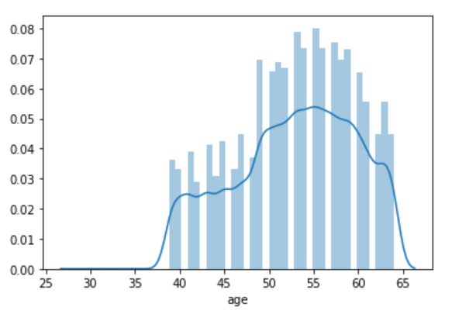

**Plot 1. Age Data**

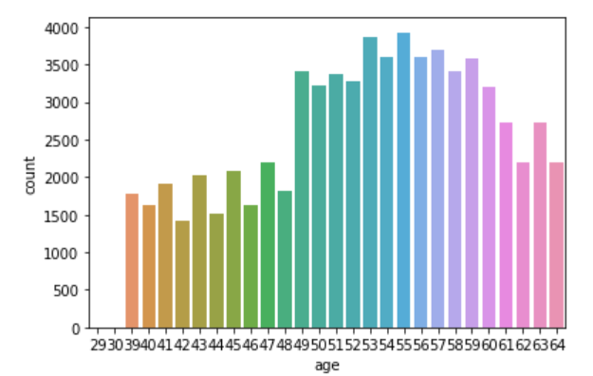

**Plot 2. Age Counts**

Plot-1 shown above signifies that data consist person ranging between age 40-64 years.

Plot-2 shown above signifies that persons more than age 48yrs and less than 61yrs has more symptoms of having heart disease.

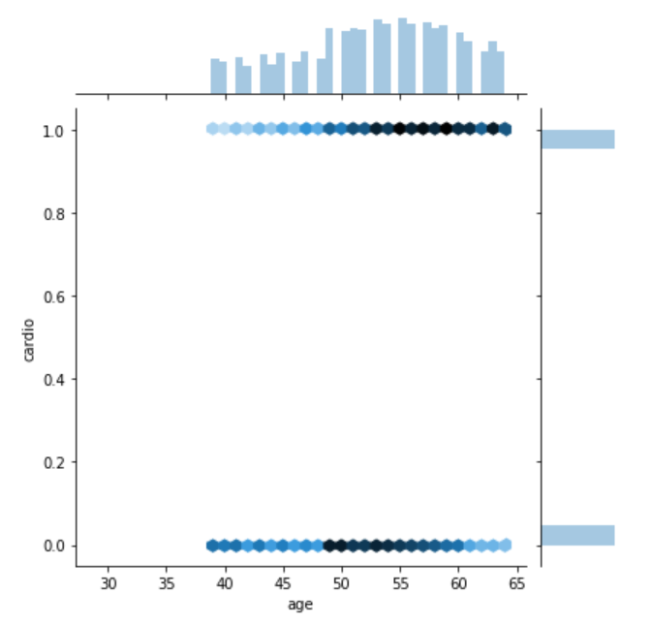

**Plot 3. Joint Plot of age vs Disease**

Plot-3 shows that the person aged between 50-65 has more chances of having Heart Disease.

The density of blue colour signifies the data points overlapping in given plot.

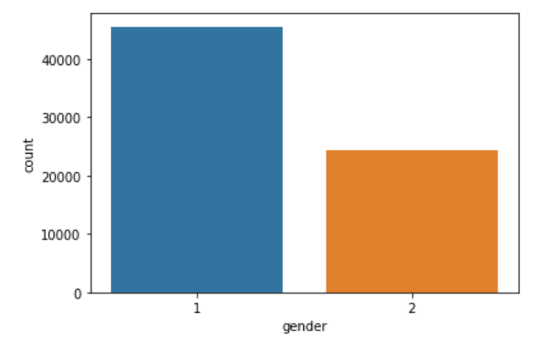

**Plot 4. Gender Counts**

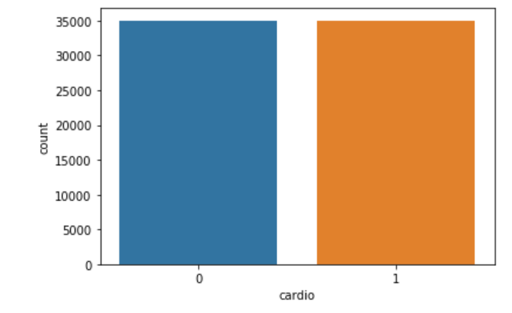

**Plot 5. Disease Counts**

Plot-4 shown above signifies that data of Males are more than Females [approx. 15000 more].

Plot-5 shown above signifies that data of both persons are equal (having a disease or not having a disease).

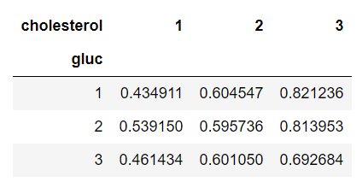

**Plot 6. Pivot Table of Glucose vs Cholesterol**

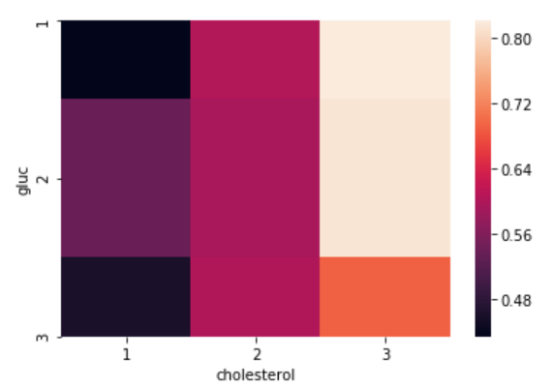

**Plot 7. Heatmap of Glucose vs Cholesterol**

Above Plots Signifies that a person having high glucose level have most chances of having high Cholesterol Level.

# CHAPTER 5

# CONCLUSION AND LIMITATIONS

**Conclusion**

This Platform provide users to check their heart’s health by providing simple features, which can be known after regular check-ups. Heart is a main organ of our body. Hence, user can get treatment on time. The portal doesn’t store any data, so it’s easy-to-go.

**Limitations**

* The accuracy of Prediction Model is 72.3%, which is not best.
* Users can get a caption of Hospitals Location just by hovering over any marker. They cannot access proper locations, or coordinates.
* Data of users made donations cannot be saved.
* No Payment Gateway is linked to Donations Page.

### **REFERENCES**

1. Aurélien Géron*, Hands-On Machine Learning with Scikit-Learn and TensorFlow,* California: O’Reilly Media, 2017.
2. Jason Brownlee, “*How to Make Predictions with scikit-learn*”, April 6, 2018, <https://machinelearningmastery.com/make-predictions-scikit-learn/>
3. CodeWithHarry, “*Python Django Tutorials*”, YouTube, Retrieved January 27, 2019, from <https://www.youtube.com/watch?v=5BDgKJFZMl8&list=PLu0W_9lII9ah7DDtYtflgwMwpT3xmjXY9/>
4. Svetlana Ulianova: Cardiovascular Disease Dataset, Jan 2019, Kaggle <https://www.kaggle.com/sulianova/cardiovascular-disease-dataset/>
5. Data Source: [United Nations - World Population Prospects](https://population.un.org/wpp/), “Death Rate” Retrieved September 16, 2020, Macrotrends <https://www.macrotrends.net/countries/IND/india/death-rate/>
6. Data Source: [United Nations - World Population Prospects](https://population.un.org/wpp/), “Growth Rate” Retrieved September 16, 2020, Macrotrends <https://www.macrotrends.net/countries/IND/india/birth-rate/>